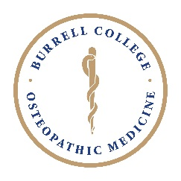
Exemption of BCOM Policy Petition

Your Information
Student Name: | Address: |  | Phone: | Email:

Request
Citation of the policy for which you are requesting an exemption.

Reason
Statement of the extenuating circumstances or reason your request should be considered. Supporting documentation is required (see below). Instead of using the space provided below, you are welcome to attach a typed statement.

Supporting Documentation
Please submit any information that supports this request.
List all supporting documents you are submitting:

- I certify that, to the best of my knowledge, all information I have provided above is accurate and correct
- I understand that I am seeking an exception to a stated college-wide academic policy, procedure, and/or regulation.
- I understand that this is a request and does not guarantee BCOM will approve the exemption of policy request. The BCOM Office of Student Affairs will make a determination as to whether the exemption will be granted.
- I assert that my extenuating circumstance(s) are evident and can be substantiated.
Student Signature: |  | Date:
Return form to: Director of Student Affairs, Brett Newcomer Room 360
Office of Student Affairs Action on Petition
- Approve
- Deny
Signature: |  | Date:
Course Director Acknowledgement
Signature: |  | Date:

